Attention
- Candidates taking the HSK test on January 8th,2022 are strictly prohibited from cross-border travel since December 26st, 2021, avoid going to epidemic and medium-high risk areas. Candidates must do a good job of self-protection, maintain a safe social distance, standardize wearing masks, and do not get together or eat together. Candidates should do a good job of health monitoring every day. Candidates prepare masks (multiple disposable medical masks or medical surgical masks), gloves, paper towels, quick-drying hand disinfectant and other protective materials in advance when they travel to the test site.
- All candidates are required to produce your Green Ankang Code and 14-day Trip Code, your admission tickets and valid passports before you enter the campus of Anhui Medical University. Candidates with Red or Yellow Ankang Code or 14-day Trip Code won’t be allowed in and can’t attend the HSK test. The registration fee won’t be returned under this circumstance.
3. Candidates should prepare the Chinese version of the "Anhui Medical University HSK Test Takers’ Health Information Commitment Letter" with signatures, Nucleic Acid detection of negative reports taken within 48 hours and submit to the invigilators on entering the classroom.
4. Candidates should cooperate with working staff to take body temperature after entering the university. If the temperature exceeds 36.8℃ (inclusive), the underarm body temperature must be retested (2 times). If the temperature exceeds 37.3℃ (inclusive) or have symptoms such as cough and fever, they must be guided to the emergency disposal site and be dealt with by on-site medical staff.
5. Candidates who fail to truthfully report your health status, fail to cooperate with the implementation of sanitation and epidemic prevention work, etc., causing serious consequences, will be held accountable in accordance with relevant laws and regulations.
6. Your admission ticket will be generated Dec.29th, 2021. It is strongly suggested that you check your personal information on the admission ticket carefully. Students with incorrect personal information on the admission ticket need to contact the test staff and modify the information before Jan. 8th. You also can provide invigilators with the the correct information on the test spot on Jan. 8th. Modification of personal information after Jan. 8th needs to be applied online and the corresponding fees should be paid.​
7. Candidates should prepare the earphones by themselves. Please check your earphones beforehand to ensure that it works. The exam center won’t provide the earphones. Prepare the earphones like the following:
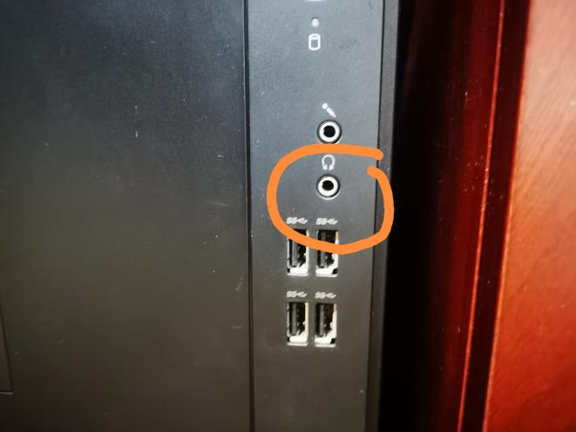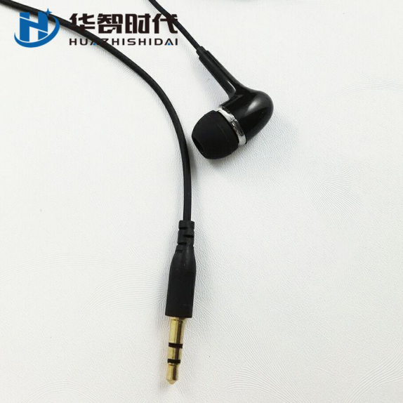
- Enter the campus through the west gate. See the guideline:
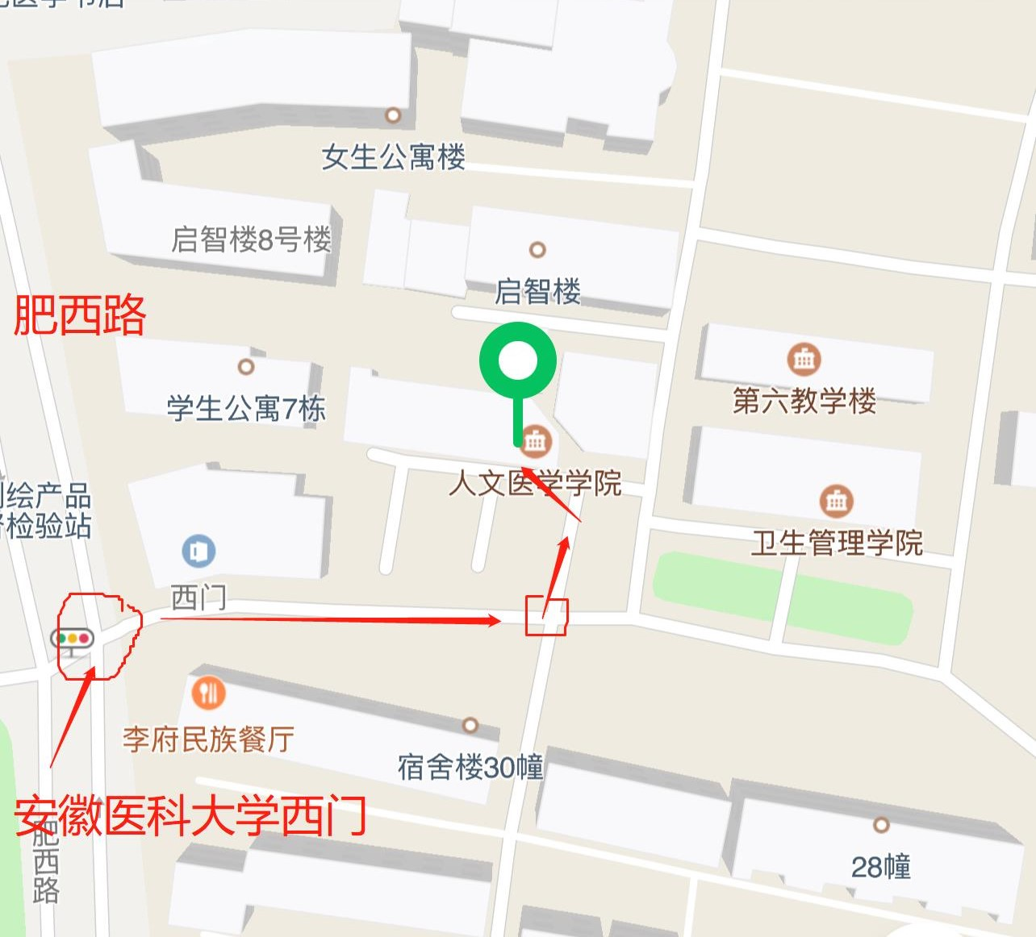

9. Candidates should come to the exam center one hour earlier at most before the scheduled time. We won’t provide the lounge for the earlier candidates!

